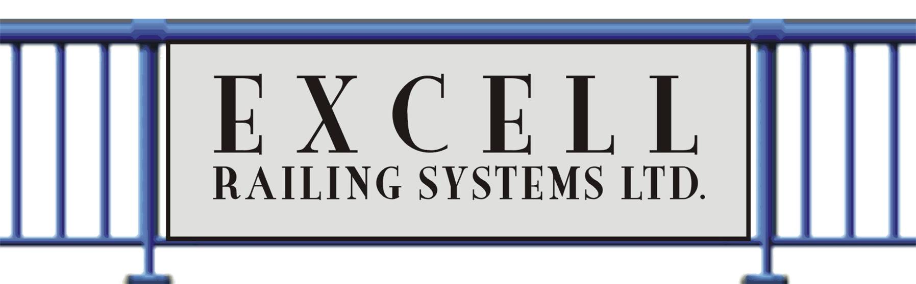
SECTION 05728

RESIDENTIAL RAILINGS – VINYL, WOOD & METAL

Display hidden notes to specifier.
** NOTE TO SPECIFIER ** Excell Railing Systems, Designer and Manufacturer of innovative, maintenance-free ornamental aluminum railing and fence systems.
.
This section is based on the products of Excell Railing Systems, which is located at:
Excell Railing Systems Ltd.
#306 – 12886 Anvil Way
Surrey, BC V3W 8E7
Tel: 604-501-0151
Fax: 604-501-0155
Toll Free: 866-999-7245
E-Mail: info@excellrailing.com
Website: www.excellrailing.com

Excell Railing Systems are an engineered railing system that exceeds the UBC and BOCA requirements for spacing and loading. We offer numerous railing models to complement virtually any architectural style, all made from the best maintenance-free parts available — powdercoated aluminum, tempered glass, and stainless steel fasteners.; contact manufacturer for additional information and specifications.
- GENERAL
  - SECTION INCLUDES
    - Component type ornamental aluminum handrails, guardrails, and railing systems, including connectors, fasteners, and required accessories.
  - PERFORMANCE REQUIREMENTS
    - Structural Performance: Engineer, fabricate, and install handrails, guardrails, and railing systems to withstand the structural loading required by applicable codes.
  - SUBMITTALS
    - Submit under provisions of Section 01300.
    - Manufacturer's specifications and installation instructions for all components of each product type specified.
** NOTE TO SPECIFIER ** Delete the following paragraph if sample submittals are not required for the project.
    - Samples: Submit samples for each railing type, profile, and color specified, not less than 6 inches (150 mm) long.
    - Shop Drawings: Prepared specifically for this project.
      - Show complete layout; plan views, elevations, connections, details for fabrication and attachment to other elements, and other installation details.
      - Include sealed drawings by the registered engineer responsible for structural design of system.
  - QUALITY ASSURANCE
    - Manufacturer/Installer Qualifications: Provide handrails, guardrails, and railing systems from one source, produced by a manufacturer and craftsmen having resources to provide consistent quality in appearance and physical properties, without delaying the work.
  - DELIVERY, STORAGE, AND HANDLING
    - Deliver handrails, guardrails, railing systems, and related components in protective packaging. Inspect materials to ensure that specified products have been received.
    - Store components to avoid damage from abrasion and other construction activities.

- PRODUCTS
  - MANUFACTURERS
      - Acceptable Manufacturer: Excell Railing Systems Ltd., which is located at: #306 – 12886 Anvil Way ; Surrey, BC, Canada V3W 8E7; Toll Free Tel: 866-999-7245; Tel: 604-501-0151; Fax: 604-501-0155; Email: info@excellrailing.com ; Web: www.excellrailing.com
    - Requests for substitutions will be considered in accordance with provisions of Section 01600.
** NOTE TO SPECIFIER ** Delete paragraph above or below; coordinate with Division 1 requirements.
    - Substitutions: Not permitted.
    - Provide all ornamental aluminum handrails, guardrails, and railing systems as approved by manufacturer.
  - MANUFACTURED UNITS
    - General: Provide products free from surface blemishes where exposed to view in the finished installation.
    - Aluminum Handrail and Railing Systems: "Excell."
** NOTE TO SPECIFIER ** Select designs from the following three subparagraphs or insert a custom design in the fourth paragraph, deleting those paragraphs not required for the project. In each design the top rail runs continuously over each support post and bottom rails are attached to the post at post interruption locations.
      - Design: Component picket system.
      - Design: Component glass system.
      - Design: Welded picket system.
      - Design: _________________________________.
** NOTE TO SPECIFIER ** Select stock color from the following eight subparagraphs, deleting those not required for the project, or delete all stock colors and insert custom color. Coordinate custom colors with the manufacturer.
      - Color: White.
      - Color: Black.
      - Color: Rideau Brown.
      - Color: Evergreen.
      - Color: Beige.
      - Color: Grey.
      - Color: Sandalwood.
      - Color: Oyster Grey.
      - Color: Textured Black.
      - Color: ______________________.
  - COMPONENTS
    - General: Provide all aluminum components of same alloy.
    - Posts: Aluminum, sizes indicated on approved shop drawings; welded bases.
    - Rails: Aluminum, sizes indicated on approved shop drawings.
      - Top rails continuous over posts.
** NOTE TO SPECIFIER ** Select profile from the following subparagraphs, unless shown on the drawings. The first two describe the "component system" and "welded picket insert system," the next two describe the "welded picket system," all referred to above. Contact the manufacturer for custom profiles and insert description in the fifth subparagraph, if required. Delete profiles not required for the project, or delete all profile subparagraphs if detailed on the drawings.
        - Profile: Excell Round.
        - Profile: Excell Square.
        - Profile: Excell Heritage.
        - Profile: _________________________.
      - Bottom Rail Profiles: Unspliced lengths between posts.
** NOTE TO SPECIFIER ** Refer to Excell product catalog for the profiles below. Select profile from the following two subparagraphs, unless shown on the drawings; the first is for the "component system," the second for the "welded system." Insert custom profile description in the third subparagraph, if required. Delete profiles not required or delete all profile subparagraphs if detailed on the drawings.
        - Profile. Welded Picket.
        - Profile. Component Picket.
        - Profile. Component Glass.
        - Profile: ______________________________.
    - Pickets: Aluminum, sizes indicated on approved shop drawings.
** NOTE TO SPECIFIER ** Include the following paragraph if glass panel inserts are required for the project. Clear tempered glass is standard, tinted tempered is optional; delete whichever subparagraph is not required. If tinted is selected, indicate tint color.
    - Panels: 1/4 inch (6 mm) tempered glass.
      - Clear.
      - ____________ tinted.
  - ACCESSORIES
** NOTE TO SPECIFIER ** Delete one of the following two paragraphs.
    - Screws: Color matched, stainless steel.
    - Screws: Color matched, cadmium plated.
    - Anchors and Inserts: As required to support work specified, in accord with approved shop drawings.
    - Fittings and Fasteners: Same basic material as parts being joined, unless otherwise indicated. Do not use metals corrosive or incompatible with materials being fastened.
  - FABRICATION
    - Fabricate handrails and railing systems to comply with manufacturer's printed requirements, project design requirements, details, dimensions, finish and member sizes, including post spacing and anchorage, but not less than the structural requirements to support loading.
    - Clearly mark component units for site assembly and installation.
    - Use connections that maintain structural capacity of joined members.
  - FINISHES
    - Powder Coated Finish: Factory electrostatically-applied, color as specified.
- EXECUTION
  - EXAMINATION
    - Examine system components, substrate, and conditions where railing systems are to be installed.
    - Notify Architect in writing of unsatisfactory conditions. Do not proceed with the work until unsatisfactory conditions have been corrected.
  - PREPARATION
    - Prepare surrounding construction to receive railing system installations to comply with manufacturer's requirements.
    - Review and coordinate setting drawings, shop drawings, templates, and instructions for assembly and installation of railing system and related items to be embedded in concrete and masonry.
  - INSTALLATION
    - Install railing system and related components in strict accordance with manufacturer's printed installation instructions and project shop drawings.

    - Preassemble railing system, including posts, pickets, and panels where shown, in easy to lift sections whenever possible.
      - Align rails so that variations from level for horizontal members, and from parallel with rake of steps and ramps for sloping members, do not exceed 1/4 inch in 12 feet (6 mm in 3.65 m).
      - Separate aluminum from building materials where electrolytic action may occur by means of asphaltic paint or other approved method.
    - Adjust, level, and securely install railing system components.
    - Provide for thermal expansion and contraction by use of expansion joints or gaps in rails. Strictly adhere to manufacturer's instructions for locations of expansion joints and fastening of expansion sleeves.
    - Install bottom rails in unspliced lengths between posts.
    - Install posts of continuous sections from mounting base to top rail.
  - CLEANING
    - Immediately upon completion of installation, clean all railing system surfaces using clean water and mild soap or detergent.
    - Do not use abrasive agent or harsh chemicals.

END OF SECTION

